UNIVERSITY OF ENGINEERING AND
TECHNOLOGY, LAHORE



SUBJECT:
Programming Fundamentals
SUBMITTED BY:
Waila Munir
2026-
Section A
SUBMITTED TO:
Miss Sawera Naz
DEPARTMENT OF COMPUTER SCIENCE UET
LAHORE

Task 02(OP):

- Create the OS folder first
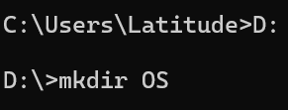

- Create the lab1 folder inside OS
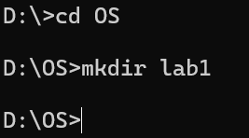

- Create four new folders of name Finance, Customer, Public, Archive
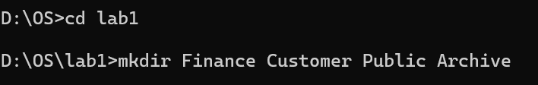

- Create two folders in Public folder of name Forms and Info
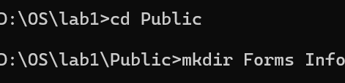

- Create Leave.txt file in Public folder
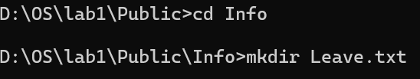

- Create three .txt files in Customer folder
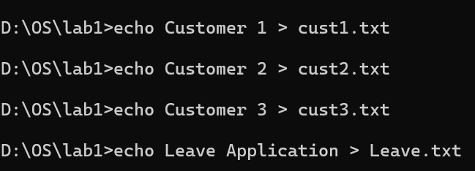

- Move the Customer files to Customer directory
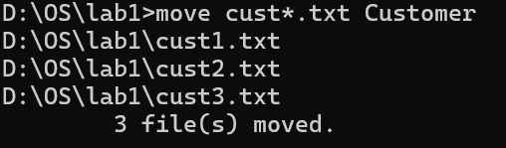

- Copy the Customer files to Archive directory using single command
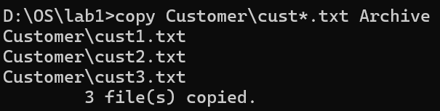

- Move the leave.txt to Archive directory and rename it leave_old.txt
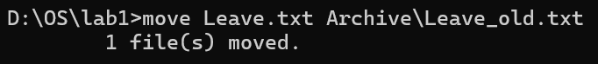

- Check that Customer directory contains three files
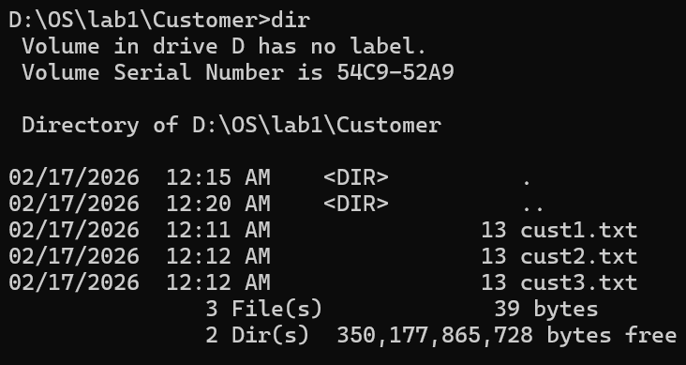

- Check Archive directory contains copied three customer files

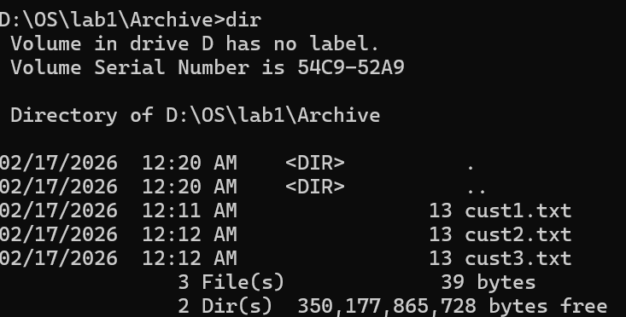

- Delete the three customer files

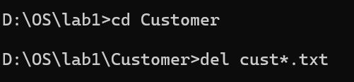

- The contents of file in the command prompt window one at a time
